1. In lec 28, we saw about @MapsId
   1. **Derived Identifier**: Id or identity derived from an entity.
   2. @MapsId annotation helps you to derive/borrow id from some other entity.
      1. To share primary key in mapping.
2. Let’s see another application of @MapsId
3. 
4. 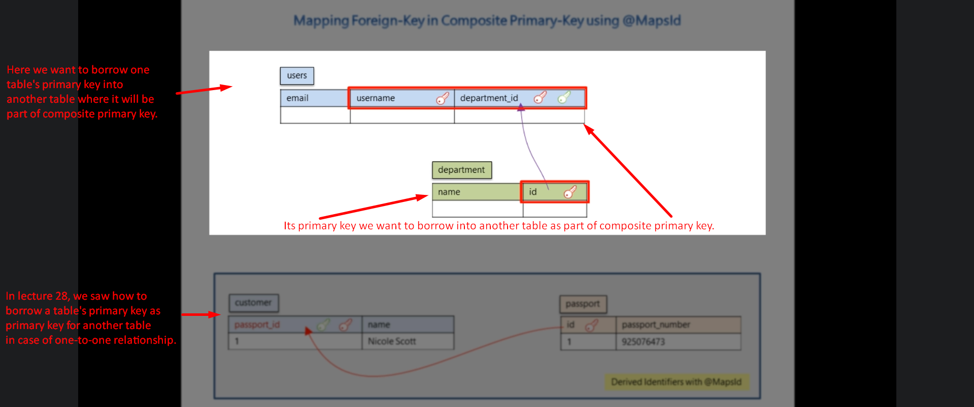
5. 
6. Start from 02:41